Lodge
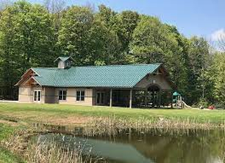
- Payment needs to be in the form of 2 separate checks – 1 for rental fee & 2 for security deposit of $175 for all rentals
- M-Th $150R/ $175NR, F, Sat, Sun $200R/$250NR – both checks get cashed
- 8am-10pm rental time
- All other information of Lodge Rental Form

Pavilion 1
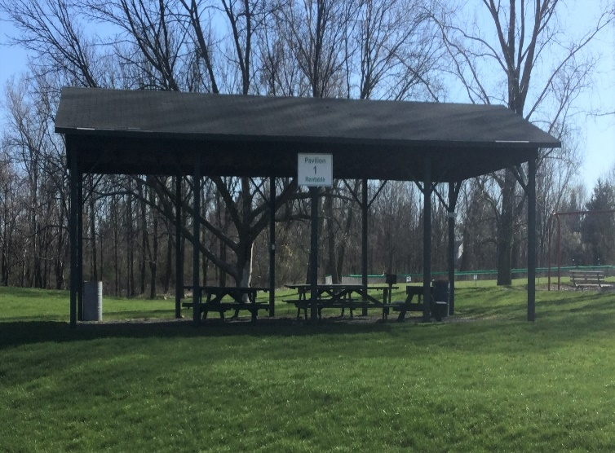
- Payment needs to be in the form of a check $25R/$35NR – no deposit required
- Located by the small baseball fields
- All day rental – if this is not rented – this can be “first come, first serve”

Pavilion 2
- Payment needs to be in the form of a check $35R/$45NR – $25 deposit required – the check doesn’t get cashed & gets returned if there is no damage
- Located across from splash pad & Baseball field #8
- All day rental
- All other information is on Rental Form

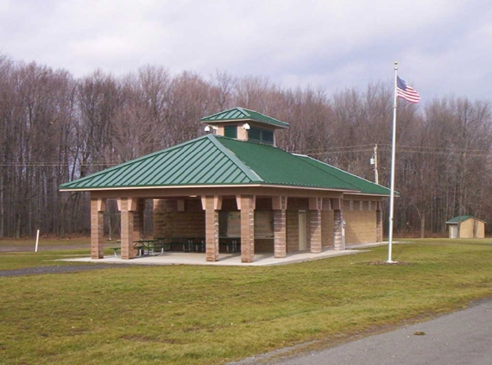
Pavilion 3
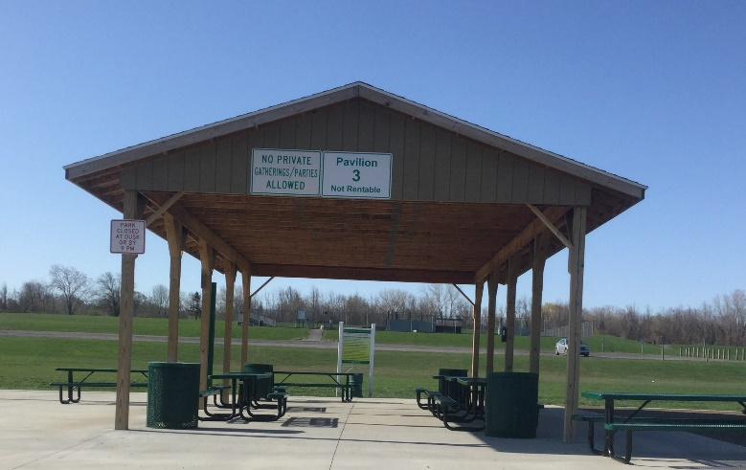
- This is not rentable. No large gatherings or parties allowed.
- This is “first come, first serve” for people using the splash pad & the inclusive playground
- This is a space to get out of sun, due to no other shade available.

